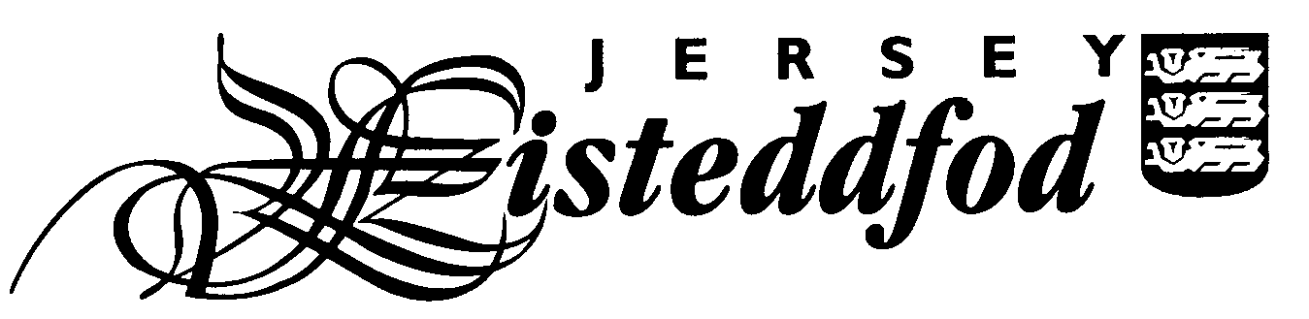
ENTRY FORM – JÈRRIAIS SECTION
For official use only
Competitor No.
JUNIOR ENTRIES (AGE 18 OR UNDER)

Closing date for entries is Friday 6th December 2024

PLEASE USE BLOCK CAPITALS

Full Name of Competitor: _________________________________________________________________

School and Year Group or Class: ____________________________________________________________

Age on 31st January 2025: ____________

Please complete the table below indicating which class numbers your child is entering and the pieces they are performing. This information can be found in the Eisteddfod section on www.jerriais.org.je or your child’s Jèrriais teacher will be able to help.

Entry fees are paid for by the Jèrriais Teaching Service and Le Don Balleine Incorporated Association.

Class No | Title of Piece | Entry Fee (for official use only)

Please tick to give permission for photographs to appear in the local media and on social media
Please tick to give permission for your child’s full name and school to be printed in the programme
and in the results article in the Jersey Evening Post

Please tick to confirm you have read the Festival Rules *

Please tick to confirm you have read the Jersey Eisteddfod Privacy Statement *

Signature of Parent: ____________________________________________________

Contact email address: __________________________________________________

Please return this form no later than Friday 6th December to your child’s Jèrriais teacher.

* You can find the Jersey Eisteddfod Privacy Statement and Festival Rules on the Jersey Eisteddfod website www.jerseyeisteddfod.org.je.
If you do not have access to the internet, you can request a paper copy from the Jèrriais Teaching Service.

